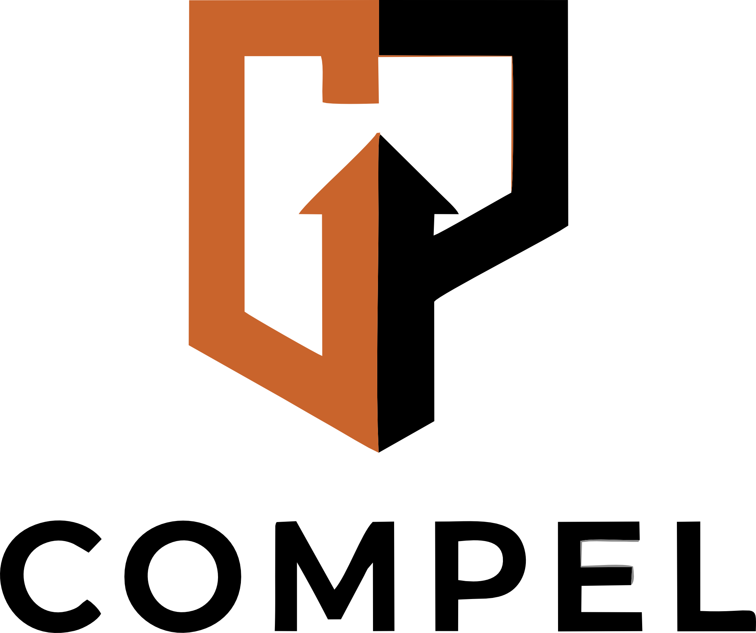
AI Procurement Questionnaire
Vendor AI Governance Assessment
COMPEL Stage: Model
EA-008
A structured questionnaire for assessing vendor AI governance capabilities during procurement. Covers data practices, model transparency, bias testing, security controls, compliance claims, and SLA terms. Ensures third-party AI meets the same governance standards as internally developed systems.

COMPEL Domains: D16: Regulatory Compliance | D17: Risk Management | D13: Security Hardening
Standards: ISO 42001 Annex A.9 | ISO 42001 Clause 8.1 | NIST AI RMF GOVERN 6.1 | EU AI Act Article 28
How to Use This Template
1. Fill in each section below with your organization's information.
2. Replace placeholder text (shown in italics) with your actual content.
3. Guidance notes (in gray boxes) provide instructions — delete them from your final version.
4. Standards references help auditors map your evidence to compliance requirements.

Vendor Profile
Basic information about the vendor and the AI product/service.
Vendor Name (text)
Guidance: Legal entity name as registered.
Acme AI Solutions Inc.
Product/Service Name (text)
Guidance: Specific product or service being evaluated, not just the vendor.
PredictPro Enterprise Analytics Platform
AI Capabilities Description (textarea)
Guidance: Request a detailed description. "AI-powered" is insufficient — you need to understand what the AI actually does.
Describe the AI capabilities within this product: what models/algorithms are used, what inputs they consume, what outputs they produce, and how those outputs are used.

Deployment Model (select)
Guidance: The deployment model affects data residency, security controls, and your ability to monitor the AI system.
Select one: ☐ SaaS (vendor-hosted) ☐ On-premises ☐ Hybrid ☐ API-only ☐ Embedded in larger platform
Data Processing Locations (textarea)
Guidance: Critical for GDPR compliance and data sovereignty requirements.
Where is data processed and stored? List all countries/regions. Are there cross-border data transfers?

Data Practices
How the vendor handles data used in AI systems.
Training Data Usage (checklist)
Guidance: This is a critical governance question. Many vendors use customer data to improve models without explicit consent. Your data governance policy likely has requirements here.
☐ Does the vendor use customer data to train or improve their models?
☐ Can customers opt out of model training using their data?
☐ Is training data anonymized/pseudonymized before use?
☐ Does the vendor use synthetic data for training?
☐ Are training data sources documented and available for review?
Data Retention (textarea)
Guidance: Ensure alignment with your data retention policies and regulatory requirements. Include model outputs and inference logs, not just input data.
What data does the vendor retain? For how long? What happens upon contract termination? Can data be exported in standard formats?

Data Security (checklist)
Guidance: Request evidence of certifications, not just claims. SOC 2 Type II reports and ISO 27001 certificates should be provided.
☐ Encryption at rest (specify standard)
☐ Encryption in transit (specify standard)
☐ Access control mechanisms
☐ Audit logging of data access
☐ Data breach notification procedures and timelines
☐ SOC 2 Type II / ISO 27001 certification status

Model Transparency and Performance
Vendor transparency about AI model design, performance, and limitations.
Model Documentation (checklist)
Guidance: Request the vendor's model card. If they cannot provide one, this is a red flag. Use the Model Card Template (EA-004) as a reference for what should be documented.
☐ Model card or equivalent documentation is available
☐ Training methodology is described
☐ Performance metrics (accuracy, precision, recall) are published
☐ Known limitations are documented
☐ Intended use cases and out-of-scope uses are defined
☐ Model versioning and changelog are maintained
Explainability (textarea)
Guidance: Explainability requirements depend on your use case. High-risk applications (credit, hiring, healthcare) typically require individual-level explanations.
Can the vendor explain individual predictions/decisions? What explainability methods are available (SHAP, LIME, feature importance)? Can explanations be provided to end users?

Performance Guarantees (textarea)
Guidance: Performance SLAs should specify metrics, measurement methodology, reporting frequency, and remedies for underperformance.
What performance metrics are guaranteed in the SLA? How is performance measured? What happens if guaranteed thresholds are not met? Is there a performance degradation notification mechanism?

Bias Testing and Fairness
Vendor's approach to bias detection, testing, and mitigation.
Bias Testing (checklist)
Guidance: Request recent bias testing reports. Ask about testing methodology — not all approaches are equally rigorous.
☐ Regular bias testing is conducted (specify frequency)
☐ Bias testing covers relevant protected characteristics
☐ Bias testing methodology is documented and available
☐ Results of bias testing are shared with customers
☐ Bias mitigation procedures are documented
☐ Customers can request bias testing for their specific data
Fairness Metrics (textarea)
Guidance: The choice of fairness metric matters. Different metrics can conflict. Ask the vendor which metric they optimize for and why.
What fairness metrics does the vendor track? (e.g., demographic parity, equalized odds, calibration across groups). Are metrics reported by demographic group?

Incident Reporting (textarea)
Guidance: A vendor that has never found bias has likely not looked hard enough. Past incident disclosure demonstrates maturity, not weakness.
Does the vendor have a process for reporting AI bias incidents to customers? What is the notification timeline? Has the vendor experienced and disclosed bias incidents in the past?

Compliance and Contractual Terms
Regulatory compliance claims and contractual governance provisions.
Regulatory Compliance Claims (checklist)
Guidance: Require evidence for every compliance claim. "Compliant" without certification or documentation is insufficient.
☐ ISO 42001 certified / in progress / roadmap
☐ NIST AI RMF aligned (provide mapping document)
☐ EU AI Act compliant (for relevant risk category)
☐ GDPR compliant (provide DPIA or privacy impact assessment)
☐ SOC 2 Type II certified (provide latest report)
☐ Industry-specific compliance (specify)
Right to Audit (textarea)
Guidance: Your ISO 42001 obligations extend to outsourced processes. You need contractual rights to verify vendor governance claims.
Does the contract include a right-to-audit clause covering AI governance? Can you audit bias testing results? Can you audit training data practices? What audit access limitations exist?

Liability and Indemnification (textarea)
Guidance: AI liability allocation is critical. Standard limitation of liability clauses may not adequately cover AI-specific risks (bias, automated decisions, regulatory penalties).
Who bears liability for AI system errors, biased outcomes, or regulatory violations? Are there indemnification provisions for AI-specific risks? Is there professional indemnity insurance covering AI outputs?

Exit Provisions (textarea)
Guidance: Vendor lock-in is a significant risk for AI systems. Ensure exit provisions cover data portability, model portability, and transition support.
What happens to your data and model outputs upon contract termination? Is there a transition period? Can you export AI configurations and training data? Is there a post-termination data deletion guarantee?

Frequently Asked Questions
Q: Should every AI vendor complete this questionnaire?
Yes, but proportionate to risk. For low-risk AI tools (e.g., grammar checking), a shortened version covering data practices and security may suffice. For high-risk AI (e.g., credit scoring, healthcare diagnostics), the full questionnaire is essential. The risk tier determines the minimum required sections.
Q: What if a vendor refuses to answer certain questions?
Vendor unwillingness to disclose is itself a risk indicator. Document the refusal and assess whether the information gap creates unacceptable risk. For high-risk applications, inability to verify vendor governance claims may be a disqualifying factor. Consider whether alternative vendors provide greater transparency.
Q: How does this relate to our existing vendor risk management process?
This questionnaire supplements (not replaces) your existing vendor risk management process. It adds AI-specific questions that standard vendor assessments miss. Ideally, integrate these questions into your procurement workflow so they are triggered automatically when a vendor product includes AI capabilities.

